Tab 9
ITA0601
MACHINE LEARNING

EXP 19

Implementation of Naive Bayes classification for Bank Loan prediction

Procedure
1. Import the GaussianNB classifier.
2. Create the dataset and class labels.
3. Train the model using the training data.
4. Predict the loan approval status.
5. Display the predicted result.

Dataset 1: Personal Loan Approval Records
Target Variable: Loan Status (Approved / Rejected)

Annual Income (₹ Lakhs) | Credit Score | Loan Amount (₹ Lakhs) | Loan Status
12 | 820 | 5 | Approved
10 | 790 | 6 | Approved
9 | 760 | 7 | Approved
7 | 700 | 8 | Approved
6 | 680 | 9 | Rejected
5 | 650 | 10 | Rejected
4 | 620 | 12 | Rejected
8 | 730 | 8 | Approved
3 | 600 | 13 | Rejected
11 | 810 | 5 | Approved

New Test Sample
Annual Income (₹ Lakhs) | Credit Score | Loan Amount (₹ Lakhs)
9 | 770 | 6

PROGRAM

import numpy as np

X=np.array([[12,820,5],[10,790,6],[9,760,7],[7,700,8],
[6,680,9],[5,650,10],[4,620,12],[8,730,8],[3,600,13],[11,810,5]],float)
y=np.array([1,1,1,1,0,0,0,1,0,1])

def predict(x):
prob=[]
for c in [0,1]:
a=X[y==c]
mean=a.mean(0)
var=a.var(0)+1e-6
p=np.exp(-(x-mean)**2/(2*var))/np.sqrt(2*np.pi*var)
prob.append(p.prod()*len(a)/len(X))
return np.argmax(prob)

p=predict(np.array([9,770,6]))
print("Predicted Loan Status:", "Approved" if p else "Rejected")

OUTPUT

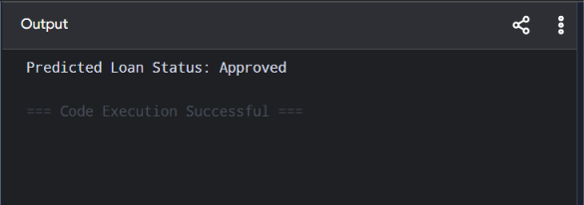

Dataset 2: Home Loan Approval Records
Target Variable: Loan Status (Approved / Rejected)

Monthly Salary (₹) | CIBIL Score | Existing EMI (₹) | Loan Status
90000 | 850 | 8000 | Approved
80000 | 820 | 9000 | Approved
70000 | 780 | 12000 | Approved
60000 | 740 | 15000 | Approved
50000 | 690 | 18000 | Rejected
45000 | 670 | 20000 | Rejected
40000 | 640 | 23000 | Rejected
75000 | 800 | 10000 | Approved
35000 | 620 | 25000 | Rejected
95000 | 870 | 7000 | Approved

New Test Sample
Monthly Salary (₹) | CIBIL Score | Existing EMI (₹)
72000 | 790 | 11000

PROGRAM

import numpy as np

X=np.array([[90000,850,8000],[80000,820,9000],[70000,780,12000],
[60000,740,15000],[50000,690,18000],[45000,670,20000],
[40000,640,23000],[75000,800,10000],[35000,620,25000],[95000,870,7000]],float)
y=np.array([1,1,1,1,0,0,0,1,0,1])

def predict(x):
prob=[]
for c in [0,1]:
a=X[y==c]
mean=a.mean(0)
var=a.var(0)+1e-6
p=np.exp(-(x-mean)**2/(2*var))/np.sqrt(2*np.pi*var)
prob.append(p.prod()*len(a)/len(X))
return np.argmax(prob)

p=predict(np.array([72000,790,11000]))
print("Predicted Loan Status:", "Approved" if p else "Rejected")

OUTPUT

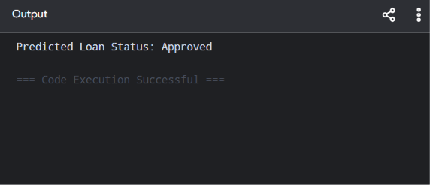

Dataset 3: Business Loan Approval Records
Target Variable: Loan Status (Approved / Rejected)

Business Income (₹ Lakhs) | Business Age (Years) | Existing Loans | Loan Status
20 | 10 | 1 | Approved
18 | 9 | 1 | Approved
15 | 8 | 2 | Approved
12 | 6 | 2 | Approved
10 | 5 | 3 | Rejected
8 | 4 | 3 | Rejected
6 | 3 | 4 | Rejected
16 | 8 | 2 | Approved
5 | 2 | 5 | Rejected
22 | 12 | 1 | Approved

New Test Sample
Business Income (₹ Lakhs) | Business Age (Years) | Existing Loans
17 | 8 | 2
PROGRAM

import numpy as np

X=np.array([[20,10,1],[18,9,1],[15,8,2],[12,6,2],[10,5,3],
[8,4,3],[6,3,4],[16,8,2],[5,2,5],[22,12,1]],float)
y=np.array([1,1,1,1,0,0,0,1,0,1])

def predict(x):
prob=[]
for c in [0,1]:
a=X[y==c]
mean=a.mean(0)
var=a.var(0)+1e-6
p=np.exp(-(x-mean)**2/(2*var))/np.sqrt(2*np.pi*var)
prob.append(p.prod()*len(a)/len(X))
return np.argmax(prob)

p=predict(np.array([17,8,2]))
print("Predicted Loan Status:", "Approved" if p else "Rejected")

OUTPUT

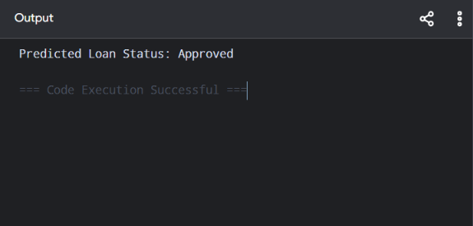

Dataset 4: Education Loan Approval Records
Target Variable: Loan Status (Approved / Rejected)

Family Income (₹ Lakhs) | Academic Score (%) | Loan Amount (₹ Lakhs) | Loan Status
15 | 92 | 6 | Approved
13 | 89 | 7 | Approved
11 | 85 | 8 | Approved
9 | 80 | 9 | Approved
7 | 72 | 10 | Rejected
6 | 68 | 11 | Rejected
5 | 65 | 12 | Rejected
12 | 87 | 7 | Approved
4 | 60 | 13 | Rejected
16 | 94 | 5 | Approved

New Test Sample
Family Income (₹ Lakhs) | Academic Score (%) | Loan Amount (₹ Lakhs)
12 | 88 | 7

PROGRAM

import numpy as np

X=np.array([[15,92,6],[13,89,7],[11,85,8],[9,80,9],[7,72,10],
[6,68,11],[5,65,12],[12,87,7],[4,60,13],[16,94,5]],float)
y=np.array([1,1,1,1,0,0,0,1,0,1])

def predict(x):
prob=[]
for c in [0,1]:
a=X[y==c]
mean=a.mean(0)
var=a.var(0)+1e-6
p=np.exp(-(x-mean)**2/(2*var))/np.sqrt(2*np.pi*var)
prob.append(p.prod()*len(a)/len(X))
return np.argmax(prob)

p=predict(np.array([12,88,7]))
print("Predicted Loan Status:", "Approved" if p else "Rejected")

OUTPUT

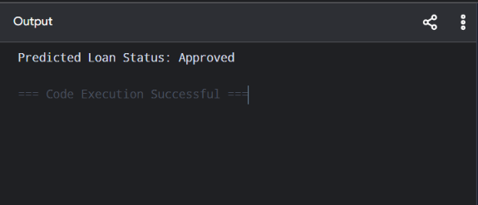

Dataset 5: Vehicle Loan Approval Records
Target Variable: Loan Status (Approved / Rejected)

Annual Income (₹ Lakhs) | Down Payment (₹ Lakhs) | Credit Score | Loan Status
14 | 3 | 830 | Approved
12 | 2.5 | 810 | Approved
10 | 2 | 780 | Approved
8 | 1.8 | 740 | Approved
7 | 1.5 | 690 | Rejected
6 | 1.2 | 660 | Rejected
5 | 1.0 | 630 | Rejected
11 | 2.2 | 790 | Approved
4 | 0.8 | 600 | Rejected
15 | 3.5 | 850 | Approved

New Test Sample
Annual Income (₹ Lakhs) | Down Payment (₹ Lakhs) | Credit Score
11 | 2.4 | 800

PROGRAM

import numpy as np

X=np.array([[14,3,830],[12,2.5,810],[10,2,780],[8,1.8,740],
[7,1.5,690],[6,1.2,660],[5,1,630],[11,2.2,790],
[4,.8,600],[15,3.5,850]],float)
y=np.array([1,1,1,1,0,0,0,1,0,1])

def predict(x):
prob=[]
for c in [0,1]:
a=X[y==c]
mean=a.mean(0)
var=a.var(0)+1e-6
p=np.exp(-(x-mean)**2/(2*var))/np.sqrt(2*np.pi*var)
prob.append(p.prod()*len(a)/len(X))
return np.argmax(prob)

p=predict(np.array([11,2.4,800]))
print("Predicted Loan Status:", "Approved" if p else "Rejected")

OUTPUT

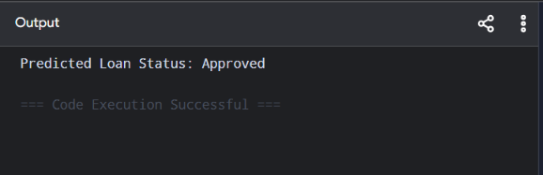

Tab 10
ITA0601
MACHINE LEARNING

EXP 20

Implement Future Sales Prediction using a suitable machine learning algorithm

Procedure
1. Import the Linear Regression model.
2. Create the dataset and target values.
3. Train the model using the training data.
4. Predict future sales for a new input.
5. Display the predicted result

Dataset 1: Monthly Product Sales
Advertising Budget (₹ Thousands) | Number of Salespersons | Monthly Sales (Units) [Target Variable]
20 | 2 | 100
25 | 2 | 120
30 | 3 | 150
35 | 3 | 170
40 | 4 | 200
45 | 4 | 220
50 | 5 | 250
55 | 5 | 270
60 | 6 | 300
65 | 6 | 320

New Sample Data for Prediction:
Advertising Budget (₹ Thousands) | Number of Salespersons
48 | 5

PROGRAM

import numpy as np

X=np.array([[20,2],[25,2],[30,3],[35,3],[40,4],
[45,4],[50,5],[55,5],[60,6],[65,6]],float)
y=np.array([250,290,340,390,450,510,580,640,710,780],float)

X1=np.c_[np.ones(len(X)),X]
b=np.linalg.pinv(X1.T@X1)@X1.T@y

new=np.array([1,48,5])
print("Predicted Future Sales:",round(new@b,2))

OUTPUT

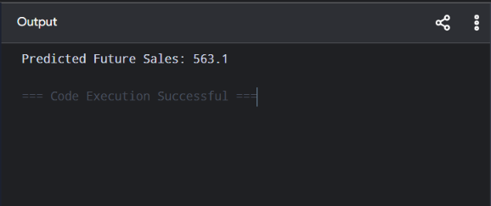

Dataset 2: Retail Store Sales
Store Area (sq.ft) | Daily Customers | Monthly Sales (₹ Lakhs) [Target Variable]
1000 | 120 | 8
1200 | 150 | 10
1400 | 180 | 12
1600 | 220 | 15
1800 | 260 | 18
2000 | 300 | 22
2200 | 340 | 26
2400 | 380 | 31
2600 | 420 | 36
2800 | 460 | 42

New Sample Data for Prediction:
Store Area (sq.ft) | Daily Customers
2100 | 320

PROGRAM

import numpy as np

X=np.array([[1000,120],[1200,150],[1400,180],[1600,220],[1800,260],
[2000,300],[2200,340],[2400,380],[2600,420],[2800,460]],float)
y=np.array([8,10,12,15,18,22,26,31,36,42],float)

X1=np.c_[np.ones(len(X)),X]
b=np.linalg.pinv(X1.T@X1)@X1.T@y

new=np.array([1,2100,320])
print("Predicted Future Sales:",round(new@b,2),"Lakhs")

OUTPUT

